EECS 4080 SU26
Project title: Detecting direct prompt injection attacks in LLM applications
Supervisor: Professor Sukhwant Kaur Sagar
Student: Thien Nguyen (219183821)

Background research

What is LLM and LLM integrated application?

LLM stands for Large Language Model and it is a category of “deep learning” models trained on massive amounts of data, which then allowing these models the capability of understanding and generating natural language (ie: any human language that has evolved naturally through daily use and communication – like English) and other types of content to perform a wide range of tasks such as: interpreting text, summarizing articles, debugging code or drafting legal documents. (Styker)

LLMs are built on a type of “neural network” architecture called “transformer” which excels at handling sequences of words and capturing text patterns. It is essentially a statistical prediction machine that continuously predicts the next word in a sequence. They learn patterns in their texts and generate language that follows those patterns. (Styker)

LLMs are capable of capturing deeper contexts, nuance, and reasoning while handling unstructured human language at scale, which differentiate them from traditional search engines and programmed systems. Once trained, LLMs can adapt to many applications and if given agentic capabilities, can also perform tasks that are otherwise be performed by humans. (Styker)

LLM can be integrated into many applications. By embedding LLM models (ie: OpenAI’s ChatGPT, Anthropic’s Claude or Meta’s LLaMA) directly into an application’s code logic to handle tasks such as text processing, natural language understanding or decision-making tasks, the LLM can function as a modular software component within a larger application infrastructure rather than operating as a standalone chatbot (like ChatGPT website) (Weber)

What is prompt injection attack? How many types of prompt injection attacks are available?

LLMs and LLMs-integrated applications are not invulnerable against malicious attacks and risks. According to OWASP top 10 risks, vulnerabilities and mitigations in 2023-2024 for developing and securing gen AI and LLM applications, Prompt Injection attacks rank #1 on the list.

Prompt injection attacks occur when a user’s prompt intentionally alter/manipulate the LLM’s behavior or outputs in unintended ways such as violating guidelines, generate harmful content, enable unauthorized access, or influence critical decisions. Prompt injections are inputs that can affect the LLM even if they are not human-visible/readable, as long as the content is parsed by the model. (genai.owasp.org)

There are 2 types of prompt injections which are direct prompt injections and indirect prompt injections. The former occurs when a user’s prompt input directly alters the behavior of the model in unintended ways. The input can be intentional (ie: malicious user deliberately crafts the prompt to exploit the model) or unintentional (ie: user’s prompt inadvertently triggers unexpected behaviour). The latter occurs when LLM accepts files or websites as inputs from external sources, and the content of these inputs when interpreted by the model will alter the model in unintended ways. Similar to direct injections, indirect injections can be either intentional or unintentional. (genai.owasp.org)

In this project, I will be focusing solely on detecting direct prompt injection attacks on LLM applications due to the time constraint of the course (3.0 credit course, completed in 14 weeks). This project aims to design, implement and benchmark a local machine learning detection framework to identify direct prompt injection attacks at the text ingestion layer before they reach an LLM application.

What is BERT and DistilBERT transformer encoder?

Since the primary ML method that will be implemented in this project is a customized DistilBERT classifier, we will first take a look at BERT as DistilBERT is a smaller, lighter and faster of BERT.

BERT (Bidirectional Encoder Representations from Transformers) was released by Google in 2018. It is a language model that learns to represent text as a sequence of vectors using self-supervised learning. It uses the encoder-only transformer architecture and is trained by masked token prediction and next sentence prediction, which gives it the capability to learn contextual, latent representations of tokens in their context. (Wikipedia)

DistilBERT is a smaller general purpose language representation model derived from BERT. It has the same architecture as BERT, can be fine-tuned with good performances on a wide range of tasks like its larger counterparts. DistilBERT is developed by Hugging Face (a collaborative AI platform and community where developers, researchers and organizations share ML models, training datasets and AI applications) by leveraging knowledge distillation during pre-training phase, and as a result, reducing the size of a BERT model by 40% while retaining 97% of its language understanding capabilities and being 60% faster. (Victor SANH)

In this project, I will customize a DistilBERT model to handle text inputs, process tokens into embedding vectors and deliver output through a binary classification (prompt benign or not).

Comparative evaluation criteria:

What is F1 score?

F1 score is a measure of the harmonic mean of precision and recall. It is commonly used as an evaluation metric in binary and multi-class classification and LLM evaluation. The F1 score integrates precision and recall into a single metric to gain better understanding of model performance.

It is specifically useful when measuring classification models’ performance when the dataset is imbalanced. And to understand why it’s useful, we’ll look at the 2 metrics it balances: Precision and Recall.

Since we’re training a model to detect malicious prompt injection attacks:

- 1/ Precision (or positive predictive value): out of all the instances the model predicted as positive (attacks), how many were actually positive? It measures the cost of false positives.

$$Recall=\frac{True Positives}{True Positives+False Positives}$$

- 2/ Recall (sensitivity): out of all the actual positive instances of the dataset, how many did the model correctly identify? It measures the cost of false negatives (missed attacks)

$$Recall=\frac{True Positives}{True Positives+False Negatives}$$

F1 score comes into play. It is the harmonic mean of Precision and Recall. Unlike simple average, the harmonic mean penalizes extreme values. If either Precision or Recall drops close to zero, the F1 score plummets as well.

$F1=2*\frac{\left( Precision*Recall \right)}{(Precision+Recall)}$

The score ranges from 0 to 1 (or 0% to 100%), where 1 is perfect Precision and Recall, and 0 is the worst possible performance.

Why is F1 helpful?
Suppose we have a dataset of 10,000 LLM prompts, where only 100 are actual attacks ( 1% ) and 9,900 are safe.

- If we build a dumb model that blindly classifies every single prompt as “Safe”, then our model has 99% accuracy (useless since it caught 0 attacks)

If we calculate F1 score for this dumb model:

- Recall = 0/100 = 0
- Precision = undefined ( or 0 because no true positives)
- F1 = 0
F1 immediately flags this model as failure, whereas Accuracy alone praises it (99%)

Now we would want both high precision and high recall ideally. But in reality, optimizing for one usually hurts the other:

- If we make detection threshold strict to avoid False Positives ( high Precision), we will miss subtle attacks ( and thus low Recall )
- If we make threshold aggressive to catch every single potential attack ( high Recall ), we will flag a lot of harmless prompts as malicious ( low Precision ).

F1 scores gives the sweet spot where both precision and recall are optimally high through a single, balanced metric. (Sharma)

False Positive Rate: this is a simple calculation by taking the number of prediction and calculate against the actual class labels in the dataset

Out-of-Distribution (OOD): model will be tested against an OOD attack family outside of training (ie: indirect injections) and the F1 score will be used.

Inference latency: I will calculate per-prompt inference latency inside my python code (using industry standard time.perf_counter() method – a stopwatch that is designed to measure microsecond-level execution differences, unaffected by background system clock changes). The stopwatch will be started right before the string token IDs into the model, then stop immediately after the model finishes generating the predictions.

Baseline comparison: customized DistilBERT will compete with ProtectAI’s DeBERTa on the same test set with F1 score or inference latency.

Direct prompt injection example flow chart:
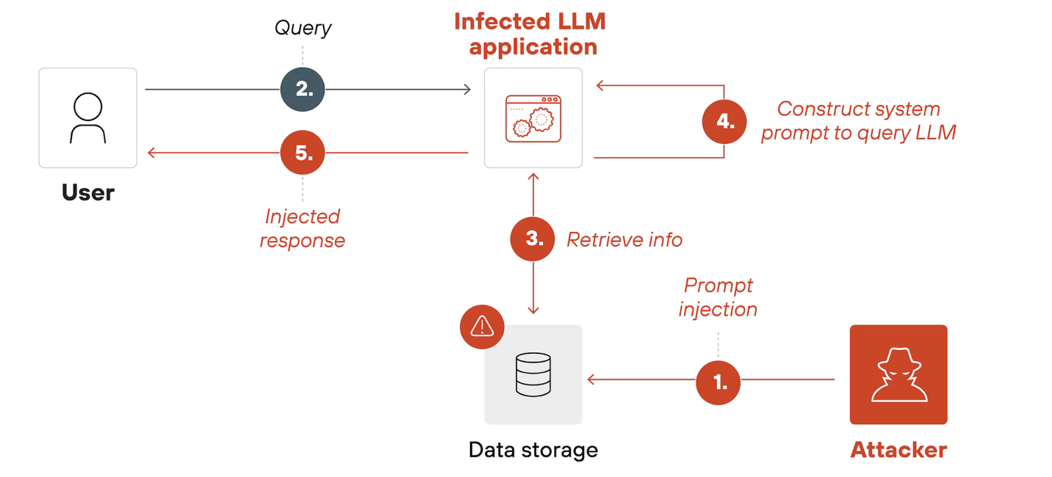Figure 1: direct prompt injection attack flow chart (paloaltonetworks.ca)

Indirect prompt injection example flow chart:
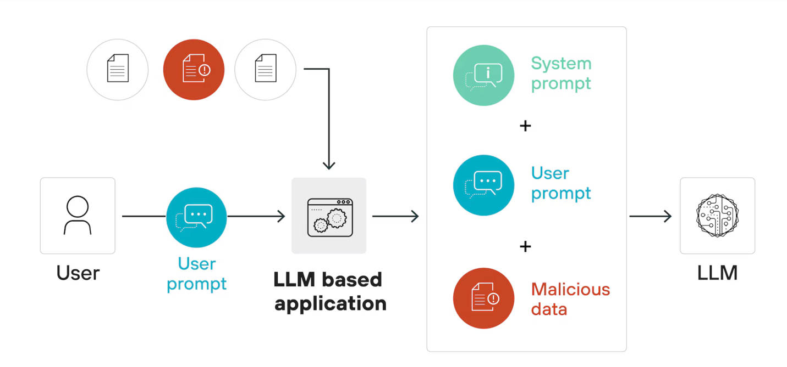
Figure 2: indirect prompt injection attack flow chart (paloaltonetworks.ca)

Works Cited
genai.owasp.org. 2025. 24 May 2026.
paloaltonetworks.ca. n.d. 24 May 2026.
Sharma, Natasha. Arize.com. 10 June 2023. 24 May 2026.
Styker, Cole. ibm.com. n.d. 23 May 2026.
Victor SANH, Lysandre DEBUT, Julien CHAUMOND, Thomas WOLF. DistilBERT, a distilled version of BERT: smaller, faster, cheaper and lighter. 1 March 2020.
Weber, Irene. "arxiv.org." 13 June 2024. Large Language Models as Software Components: A Taxonomy for LLM-Integrated Applications. 23 May 2026.
Wikipedia. n.d. 24 May 2026.

Formalizing prompt attack threat model:

Visual Architecture & Trust Boundary Diagram
TRUSTED ZONE (Local DistilBERT model)

System configuration
UNTRUSTED ZONE (User space)

End-user/ Threat:
Direct injection payloads

Evaluation metric (F1, FPR, Latency
Experimental Performance Report
Model3:
Local LLM-as-a-Judge (Phi-3-mini)
Model4:
Off-the-shelf ProtectAI DeBERTa
Model2:
Vector Space Embedding + ML classifier
Model1:
Customized DistilBERT
Evaluation Benchmarking Suite
(Simultaneous execution loop across 4 approaches)
Data Processing Pipeline
(Tokenization, Padding, EDA)
Secure ingestion
Text input string
Trust boundary

